Prompt：Please follow the SOP. The object is a blue material transfer bin. The Pick Station is Placement Point 1, and the Place Station is Place Station 2.

JCIIOT 2026 Standard Operating Procedure (SOP)
Electronics Factory Material Handling Task Execution Manual
Task Name: Material Handling Task
Task Number: SOP-ELC-001-2026-GEN
Version: 2.0
Effective Date: April 23, 2026
Applicable Scenario: Electronics Factory Material Handling Operations
Document Attribute: Standard Execution Document

I. Document Purpose
This Standard Operating Procedure is intended to guide operators or automated handling equipment to complete material handling tasks in an electronics factory according to unified requirements. By standardizing the execution process, it ensures that the material handling process from the starting point to the end point meets the following requirements:
- Safe and controllable
- Reasonable path
- Accurate grasping
- Stable placement
- Traceable anomalies
This document is applicable to single or continuous material handling operations and can also serve as a basis for training, demonstrations, project delivery, and on-site execution.

II. Task Overview
In this task, the executing entity needs to grasp the target material from a designated starting point and safely transport it to a designated end point for placement. During execution, real-time attention must be paid to environmental changes, path status, and material stability to avoid anomalies such as collisions, drops, mis-grasps, or mis-placements.
2.1 Task Objective
Transport the target material from the Pick Station to the Place Station, ensuring the entire process complies with standard requirements.
2.2 Core Requirements
- Correctly identify the target material.
- Safely arrive at the starting point.
- Accurately complete grasping.
- Stably complete transportation.
- Precisely complete placement.
- Complete operation records and wrap-up.

III. Pre-Operation Preparation
3.1 Task Information Confirmation
Before starting the operation, the following should be confirmed:
- Whether the current task has been issued.
- Whether the starting point is the Pick Station.
- Whether the end point is the Place Station.
- Whether the target material type has been clearly defined.
- Whether the quantity to be transported has been clearly defined.
3.2 Target Material Identification
Before execution, the material to be handled should be confirmed according to the task prompt, and the following should be identified:
- Material appearance characteristics.
- Color, shape, or label information.
- Current location.
- Whether the graspable area is clear.
3.3 Equipment Status Confirmation
Before starting the task, the following equipment checks should be completed:
- Navigation system is normal.
- Gripping mechanism is normal.
- Visual recognition function is normal.
- Safety protection function is normal.
- No abnormal conditions around the equipment affecting operation.
3.4 Environmental Status Confirmation
The work site should be confirmed to meet execution conditions:
- Aisles are clear.
- Grasping area is unobstructed.
- Placement area is unoccupied.
- No obvious safety hazards nearby.
- Lighting and visibility conditions meet requirements.

IV. Standard Operating Procedures
Step 1: Proceed to the Starting Point (Pick Station)
Operation Requirements:
- Initiate the task execution process.
- Navigate to the designated starting point, Pick Station.
- Stop upon arrival and enter the identification-ready state.
- Check if the surrounding environment of the starting point is suitable for grasping operations.
Key Checks:
- Is the starting point location correct?
- Is the work area tidy?
- Is the target material in an identifiable and graspable state?
- Are there any obstacles or interference risks?

Step 2: Identify and Grasp the Target Material
Operation Requirements:
- Activate the identification function at the Pick Station.
- Precisely locate the target material.
- Analyze the material's posture, boundaries, and grasping conditions.
- Plan the grasping path to ensure no contact with other objects nearby.
- Execute the grasping action smoothly and precisely.
- After grasping, confirm that the material is firmly held.
Key Checks:
- Was the correct material grasped?
- Is the grasping point appropriate?
- Did any collision occur during grasping?
- Is there a risk of the material slipping?
- Is the posture stable after clamping?
Execution Requirements:
- Actions should be smooth.
- Do not grasp roughly.
- Do not mistakenly grasp non-target materials.
- Do not cause interference due to insufficient path planning.

Step 3: Navigate to the End Point (Place Station)
Operation Requirements:
- After grasping, plan the path from the Pick Station to the Place Station.
- Prioritize safe, smooth, and low-risk transportation routes.
- Continuously monitor environmental changes during transportation.
- Promptly decelerate, stop, or re-plan the path when encountering obstacles.
- Ensure the material remains stable throughout the entire transportation process.
Key Checks:
- Is the path safe and feasible?
- Are there any temporary obstacles?
- Is the material shaking?
- Is there a risk of collision with surrounding equipment or objects?
- Is it always operating in a controlled state?
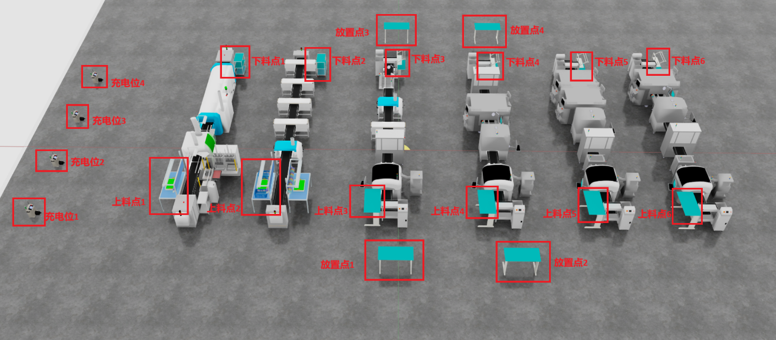
Step 4: Precisely Place the Material at the Place Station
Operation Requirements:
- Upon arriving at the Place Station, first inspect the placement area.
- Confirm that there are no other interferences or occupied spaces in the end point area.
- Move the material above the designated placement position.
- Slowly lower and complete the placement.
- Gently release the gripper, ensuring the material lands smoothly.
- After placement, re-confirm the material's status.
Key Checks:
- Is the placement area clean and available?
- Is the material placed within the designated area?
- Is there any tilting, shifting, or exceeding boundaries?
- Is the material stable after release?
- Does the completed placement affect subsequent operations?
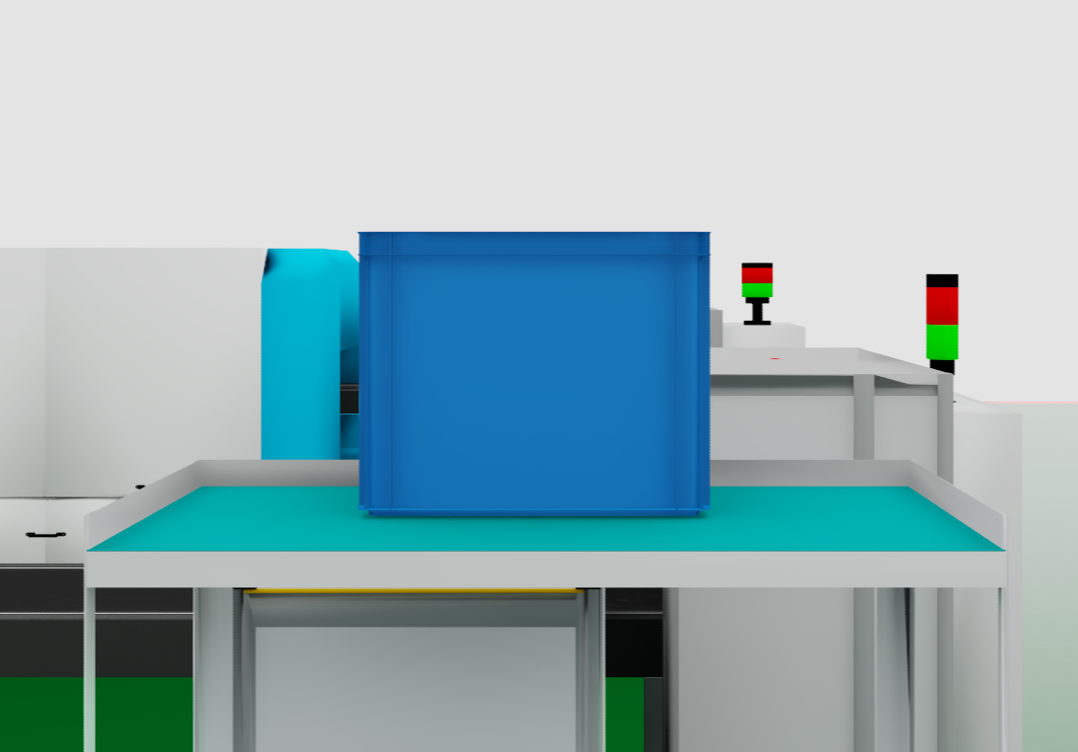
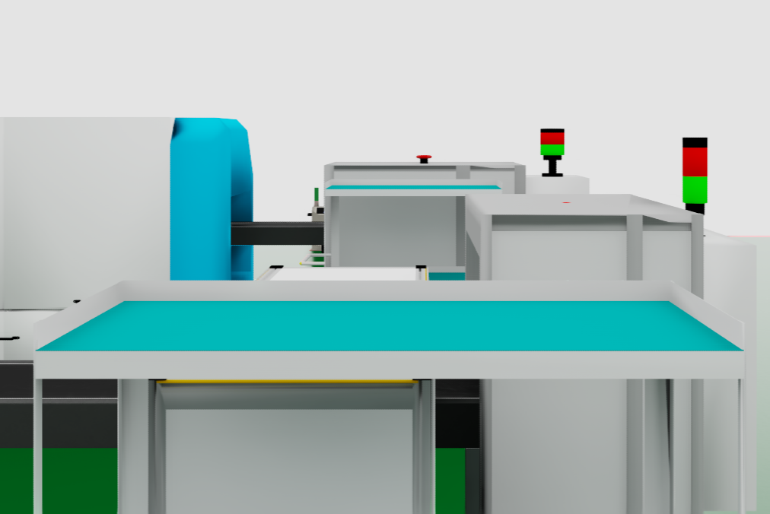
Step 5: Repeat Handling Task (if applicable)
Operation Requirements:
- If the task requires handling multiple materials, return to the grasping process to continue execution.
- Each handling cycle should re-complete identification, grasping, transportation, and placement confirmation.
- Each cycle should independently ensure quality and safety requirements.
Notes:
- Do not omit inspection steps.
- Do not ignore anomaly prompts during continuous operation.
- The completion status of each material should be confirmed individually.

Step 6: Task Completion and Wrap-up
Operation Requirements:
- Confirm that all target materials have been transported.
- Verify that the completed quantity matches the task requirements.
- Return to the designated standby area, or prepare to execute the next task.
- Record the task completion status and process information.
- If there are anomalies, supplement with anomaly descriptions.
Key Checks:
- Has all material been transported?
- Are there any omissions, misplacements, or over-transportation?
- Has the equipment returned to standby state?
- Are the records complete?

V. Anomaly Handling Instructions
5.1 Collision Occurs
If a collision occurs during movement or operation, the following procedure should be executed immediately:
- Immediately Stop Action.
- Inspect Material, Equipment, and Site Status.
- Assess if Execution Can Continue.
- Attempt to Re-plan a Safe Path.
- If Unable to Recover, Report Anomaly Promptly.
5.2 Material Drops
If material drops during transportation, the following procedure should be executed:
- Immediately Stop Operation.
- Assess Material Status and Surrounding Environment.
- If Safe to Re-grasp, Re-execute Grasping.
- If Not Safe to Handle, Report Anomaly and Await Further Instructions.
5.3 Path Obstructed
If an obstacle appears in the path, the following procedure should be executed:
- Decelerate or Stop.
- Re-identify the Surrounding Environment.
- Plan an Alternative Path.
- If No Feasible Path, Pause Task and Report.
5.4 SOP Discrepancy with Site Conditions
If a discrepancy is found between the SOP description and the actual environment, the following procedure should be executed:
- Immediately Stop Operation.
- Report to Site Supervisor.
- Describe Discrepancies in Detail.
- Await Further Instructions.
- Do Not Adjust Procedures Without Confirmation.

VI. Safety Requirements
6.1 Basic Safety Principles
- Safety takes precedence over efficiency.
- Do not force continuation under any abnormal conditions.
- Continuous attention to environmental changes must be maintained.
- Risks to personnel, equipment, and materials must be avoided.
6.2 Handling Safety Requirements
- Material must not be dropped.
- Material must not collide.
- Material must not shake violently.
- Do not continue transportation if grasping is unstable.
6.3 Placement Safety Requirements
- The area status must be confirmed before placement.
- Placement must be slow and stable.
- Stability must be confirmed after placement.
- Placement results must not exceed the designated range.

VII. Quality Requirements
To ensure the quality of task completion, the following requirements must be met during execution:
- Target material identified correctly.
- Grasping action executed successfully.
- Transportation process free of collisions and drops.
- Placement position accurate.
- Placement result stable.
- Entire process recorded completely.

